PATIENT INFORMATION
(Confidential Information – Important for Our Files and Your Health)
(Please Print)
Date / /
^{MONTH} ^{DAY} ^{YEAR}
Patient Date of Birth / /
^{LAST} ^{FIRST} ^{INITIAL} ^{MONTH} ^{DAY} ^{YEAR}
Parent or Guardian (if patient is a minor):
^{LAST} ^{FIRST} ^{MIDDLE}
Home Address Telephone # ( )
Cell Phone #
City State Zip
Sex: Male Female Marital Status: Single Married Divorced Widowed
Email:
Patient Employed by Occupation
Business Address City State Zip
Business Telephone # ( ) Social Security No. - -
Name of Spouse Social Security No. - -
Spouse Employed by Business Telephone # ( )
Business Address
Do you have medical insurance? Yes No Are you insured? Yes No Or a dependent?
WHOM MAY WE THANK FOR REFERRING YOU TO THIS OFFICE?
Name Address
HOW DID YOU HEAR ABOUT THIS OFFICE?

Insurance Information

Name of Primary Insurance
Policy Identification # Group #
Subscriber’s name (other than the patient) Relation

Name of Secondary Insurance
Policy Identification # Group #
Subscriber’s name (other than the patient) Relation

Do you have a prescription insurance policy (card)? Yes No

Medical History

Family Physician
Has he / she requested you be seen in our office?
If DIABETES: When was the last visit to your primary physician?
Former Podiatrist
What did he / she treat you for?

Pre-History Form

- State in your words your medical reason(s) for coming to our office.

- Please list all medicines that you use.

- FOR WOMEN ONLY: Are you pregnant? If so, how many months?

- Family history: Please indicate the health or cause of death of members of your family as best you can.

Age if Age At Indicate Any Cause of
Living Death Serious Diseases Death
Mother
Father
Brothers
Sisters
Children
Spouse
Others

Indicate which of your relatives have had any of the following disease:

Cancer Diabetes
Heart Trouble High Blood Pressure
Kidney Disease Mental / Emotional Disease
Strokes Arthritis

- Please indicate by checking “yes” or “no” if you have had significant problems in the below areas. Please comment on special problems.
Yes | No | Nature of Problem | Comment and Give Approximate Date
 |  | Recent Weight Loss
 |  | Headaches
 |  | Trouble w/ Vision
 |  | Trouble w/ Hearing
 |  | Allergies / Hay fever
 |  | Asthma
Allergic Reaction
to Medications
 |  | Thyroid
 |  | Diabetes
 |  | Skin
Anemia or
Abnormal Bleeding
 |  | Heart
 |  | Circulation
 |  | High Blood Pressure
 |  | Chest Pain
Lungs
(Pneumonia, T.B., etc.)
Shortness of Breath
(Cough, Pleurisy, Wheezing)
Liver Disease, Gallbladder
Disease (of Jaundice)
 |  | Stomach Trouble
 |  | Swelling in Feet or Ankles
Kidney Disease
or Stones
 |  | Gout
 |  | Double Jointed
 |  | Numbness in Feet or Legs
 |  | Cramps in Feet or Legs
 |  | Low Back Pain
Do you Smoke?
Did you quit smoking?
How many years do / did smoke?
How much (# packs / day)?

Yes No Nature of Problem Comment and Give Approximate Date
Do You Drink Alcohol?
How Much?
Do You Take Any Drugs not prescribed by a physician?
(Legal or Illegal)
How Much?
Cancer, what type?
Depression
Psychiatric
Fainting or Convulsions
Strokes
Pain in Other Areas
Other Illnesses
or Problems

- Please give details of any –
 | Approximate Date | Surgeon | Hospital
Operations
Serious Injuries

- Have you previously had physical therapy? Please describe.

- Please inform us of any other important information.

- Is there anything you wish to tell your physician privately? Yes No
BILLING POLICY

We are committed to providing you with the best possible care. In order to achieve these goals we need your assistance and your understanding of our billing policy.

As a courtesy to you, we submit our claims for services rendered to your insurance carrier for you whether or not we have a participation agreement with that carrier. We participate with HGS Administrators (Medicare), Highmark Blue Shield, Access (Medicaid); and Keystone Health Plan East. We do not accept payments as payment-in-full if we are NOT a participating provider with that plan. Not all services are a covered benefit by all insurance companies; therefore, any services not covered by your insurance will by your responsibility.

As per the terms of our contract with a managed care plan or insurance company (or Federal law as it pertains to HGS Administrators for the 20% co-insurance), we are to bill the patient for any “allowable” fees not covered by the plan including co-insurance, co-payments, deductibles, etc. (Note: Your insurance is a contract between you, your employer and the insurance company. If you as participant do not pay these amounts, you are in violation of your contract with your insurance company.)

FOLLOWING IS AN OUTLINE OF OUR POLICY:

- Payment is expected upon receipt of your first billing statement. We realize that temporary financial problems may affect timely payment of your account. If such problems do arise, we encourage you to contact the office manager promptly for assistance in setting up a signed budget agreement to pay off the balance within six months.

Please be informed that a charge of $40.00 will be served to you for non-sufficient / uncollected funds.

- If 30 days passed and the balance is not paid, the account is considered “past due.” We will attempt to contact you by phone (at home, at work or via your emergency contact person – in this order) during normal business hours concerning non-payment.

- If another 30 days passes and balance is not paid (or partial payment if a budget agreement has been set up), the account is considered “delinquent,” and further action to collect the balance may have to be taken. You will receive notification on your billing statement.

It is your responsibility to notify us promptly of any address or telephone changes. Sometimes the information we have is incorrect, so we will ask for insurance card at the time of your follow-up visit. Please notify us immediately if know there are any discrepancies. We are available to assist you between the hours of 9:00 a.m. and 5:00 p.m. Monday through Friday. If you call us at any other time, you can leave a voice mail message and your telephone number, and we will call you back promptly. Call (215) 659-1610

ASSIGNMENT AND RELEASE

I, the undersigned, have insurance coverage with

(NAME OF INSURANCE COMPANY)
Assign directly to DR. MARTIN S. HERSH all medical benefits, if any otherwise payable to me for services rendered. I understand that I am financially responsible for all charges whether or not paid by insurance. I hereby authorize the doctor to release all information necessary to secure payment of benefits. I authorize the use of this signature on all of my insurance submissions.

I attest by my signature below, that the information in this document- given freely and without coercion- is complete to the best of my knowledge.

PATIENT’S SIGNATURE DATE

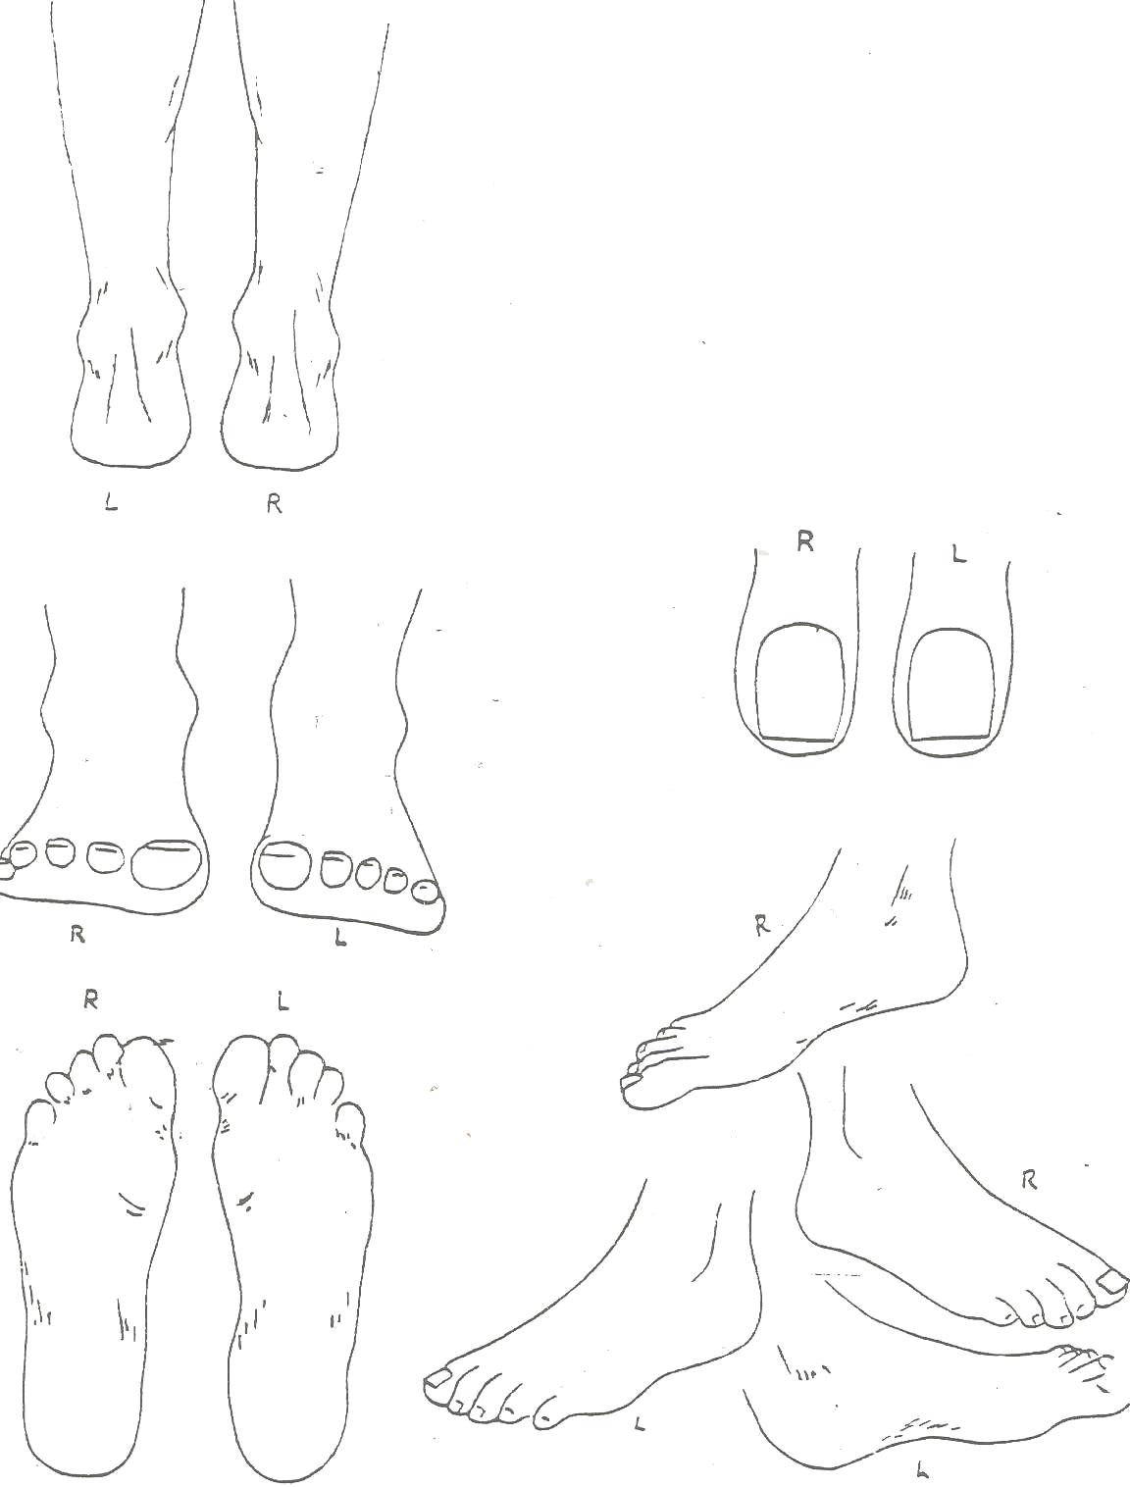
Please indicate your foot problem(s) by circling the area on the drawing.

PATIENT’S INITIALS DATE

OFFICE POLICY

It is the purpose of the staff in our office to provide for your foot health as thoroughly and efficiently as possible.
The initial appointment is spent conducting a thorough examination so that we can evaluate your condition as to diagnosis and the proper treatment.
This office treats ALL CONDITIONS which affect the feet, including fractures, and specializes in the surgical correction of the lower extremities.
Our services will be performed using the most modern diagnostic aids. When necessary, we will take x-rays to insure a complete understanding of the problems presented. X-rays and medical records are the property of this office. Duplicates will be supplied at nominal charge.
It is important to discuss your insurance protection coverage so that you will receive the proper benefits from your policy.
It is customary to pay for professional services when rendered. Deferred payment arrangements must be made in advance of treatment.
Patients are seen by appointment only. If you must change the appointment, you must notify the office at least 24 hours in advance. Otherwise, you will be charged.
In case of EMERGENCY (e.g. injury, fracture, or infection) call the office immediately. Our emergency facilities are available to our patients on a 24 (twenty-four) hour basis.
If at any time you have a question regarding treatment, fee or service, please discuss this with us promptly.
We appreciate your patronage to this office…
Dr. Martin S. Hersh, D.P.M. & ASSOCIATES
Physician Attestation
I attest that I have thoroughly read and reviewed the information contained in this document. Furthermore, I attest that I have reviewed this information with the patient.

Dr. Martin S. Hersh, D.P.M. DATE

